

CSA0905 JAVA PROGRAMMING

Ramya K
192311149

EMPLOYEE.JAVA
PACKAGE APPLICATION
package Application; public class Employee {
private int employeeId; private String name; private String gender; private String dob; private String contact; private String email; private String address; private String department;
private String designation; private String joiningDate; private double basicSalary; private double allowances; private double deductions; private String status;

public Employee() {
}

public Employee(int employeeId, String name, String gender, String dob, String contact, String email, String address,
String department, String designation, String joiningDate, double basicSalary, double allowances,
double deductions, String status) {

this.employeeId = employeeId; this.name = name;
this.gender = gender;

this.dob = dob; this.contact = contact; this.email = email; this.address = address;
this.department = department; this.designation = designation; this.joiningDate = joiningDate; this.basicSalary = basicSalary; this.allowances = allowances; this.deductions = deductions; this.status = status;
}

public int getEmployeeId() { return employeeId;
}

public void setEmployeeId(int employeeId) { this.employeeId = employeeId;
}

public String getName() { return name;
}

public void setName(String name) { this.name = name;
}

public String getGender() { return gender;
}

public void setGender(String gender) { this.gender = gender;
}

public String getDob() { return dob;
}

public void setDob(String dob) { this.dob = dob;

}

public String getContact() { return contact;
}

public void setContact(String contact) { this.contact = contact;
}

public String getEmail() { return email;
}

public void setEmail(String email) { this.email = email;
}

public String getAddress() { return address;
}

public void setAddress(String address) { this.address = address;
}

public String getDepartment() { return department;
}

public void setDepartment(String department) { this.department = department;
}

public String getDesignation() { return designation;
}

public void setDesignation(String designation) { this.designation = designation;
}

public String getJoiningDate() {

return joiningDate;
}

public void setJoiningDate(String joiningDate) { this.joiningDate = joiningDate;
}

public double getBasicSalary() { return basicSalary;
}

public void setBasicSalary(double basicSalary) { this.basicSalary = basicSalary;
}

public double getAllowances() { return allowances;
}

public void setAllowances(double allowances) { this.allowances = allowances;
}

public double getDeductions() { return deductions;
}

public void setDeductions(double deductions) { this.deductions = deductions;
}

public String getStatus() { return status;
}

public void setStatus(String status) { this.status = status;
}
}

DBCONNECTION.JAVA
package org.example; import java.sql.Connection;
import java.sql.DriverManager; import java.sql.SQLException;

public class DBConnection {

public static Connection getConnection() {

Connection con = null;

try {
Class.forName("com.mysql.cj.jdbc.Driver");

con = DriverManager.getConnection( "jdbc:mysql://localhost:3306/employee", "root",
"""
MySQL@123"""
);

} catch (ClassNotFoundException e) { throw new RuntimeException(e);

} catch (SQLException e) {
throw new RuntimeException(e);
}

return con;
}
}

EMPLOYEEMANAGEMENT.JAVA
import Application.Employee;

import java.awt.*; import java.awt.event.*; import java.sql.ResultSet;

public class EmployeeManagement extends Frame {

Label lblTitle, lblId, lblName, lblGender, lblDob, lblContact; Label lblEmail, lblAddress, lblDept, lblDesignation, lblJoining; Label lblBasic, lblAllowance, lblDeduction, lblStatus;

TextField txtId, txtName, txtDob, txtContact, txtEmail; TextField txtAddress, txtDept, txtDesignation, txtJoining;

TextField txtBasic, txtAllowance, txtDeduction;

Choice genderChoice; Choice statusChoice;

Button btnAdd, btnSearch, btnUpdate, btnDelete; Button btnClear, btnView, btnPayroll;

TextArea txtArea;

public EmployeeManagement() {

setTitle("Employee Management and Payroll Application"); setSize(1000, 700);
setLayout(new BorderLayout(10, 10));

lblTitle = new Label("EMPLOYEE MANAGEMENT AND PAYROLL SYSTEM", Label.CENTER);
lblTitle.setFont(new Font("Arial", Font.BOLD, 22)); add(lblTitle, BorderLayout.NORTH);
Panel formPanel = new Panel(); formPanel.setLayout(new GridLayout(8, 4, 8, 8));

lblId = new Label("Employee ID"); txtId = new TextField();

lblName = new Label("Name"); txtName = new TextField();

lblGender = new Label("Gender"); genderChoice = new Choice(); genderChoice.add("Male"); genderChoice.add("Female");

lblDob = new Label("Date of Birth"); txtDob = new TextField();
lblContact = new Label("Contact Number"); txtContact = new TextField();

lblEmail = new Label("Email"); txtEmail = new TextField();

lblAddress = new Label("Address"); txtAddress = new TextField();

lblDept = new Label("Department"); txtDept = new TextField();

lblDesignation = new Label("Designation"); txtDesignation = new TextField();

lblJoining = new Label("Date of Joining"); txtJoining = new TextField();

lblBasic = new Label("Basic Salary"); txtBasic = new TextField();

lblAllowance = new Label("Allowances"); txtAllowance = new TextField();
lblDeduction = new Label("Deductions"); txtDeduction = new TextField();

lblStatus = new Label("Employment Status"); statusChoice = new Choice(); statusChoice.add("Active"); statusChoice.add("Inactive");

formPanel.add(lblId); formPanel.add(txtId); formPanel.add(lblName); formPanel.add(txtName);

formPanel.add(lblGender); formPanel.add(genderChoice); formPanel.add(lblDob); formPanel.add(txtDob);

formPanel.add(lblContact); formPanel.add(txtContact); formPanel.add(lblEmail); formPanel.add(txtEmail);

formPanel.add(lblAddress);

formPanel.add(txtAddress); formPanel.add(lblDept); formPanel.add(txtDept);

formPanel.add(lblDesignation); formPanel.add(txtDesignation); formPanel.add(lblJoining); formPanel.add(txtJoining);

formPanel.add(lblBasic); formPanel.add(txtBasic); formPanel.add(lblAllowance); formPanel.add(txtAllowance);

formPanel.add(lblDeduction); formPanel.add(txtDeduction); formPanel.add(lblStatus); formPanel.add(statusChoice);

Panel buttonPanel = new Panel(); buttonPanel.setLayout(new FlowLayout());

btnAdd = new Button("Add"); btnSearch = new Button("Search"); btnUpdate = new Button("Update"); btnDelete = new Button("Delete"); btnClear = new Button("Clear"); btnView = new Button("View All"); btnPayroll = new Button("Payroll");

buttonPanel.add(btnAdd); buttonPanel.add(btnSearch); buttonPanel.add(btnUpdate); buttonPanel.add(btnDelete); buttonPanel.add(btnClear); buttonPanel.add(btnView); buttonPanel.add(btnPayroll);

Panel centerPanel = new Panel(); centerPanel.setLayout(new BorderLayout(10, 10));

centerPanel.add(formPanel, BorderLayout.NORTH); centerPanel.add(buttonPanel, BorderLayout.CENTER);

add(centerPanel, BorderLayout.CENTER);

txtArea = new TextArea(); txtArea.setEditable(false); add(txtArea, BorderLayout.SOUTH);

addWindowListener(new WindowAdapter() { public void windowClosing(WindowEvent e) {
dispose();
}
});

btnAdd.addActionListener(new ActionListener() { public void actionPerformed(ActionEvent e) {

try {

if (txtId.getText().isEmpty() || txtName.getText().isEmpty() || txtDob.getText().isEmpty() || txtContact.getText().isEmpty() || txtEmail.getText().isEmpty() || txtAddress.getText().isEmpty() || txtDept.getText().isEmpty() || txtDesignation.getText().isEmpty() || txtJoining.getText().isEmpty() || txtBasic.getText().isEmpty() || txtAllowance.getText().isEmpty() || txtDeduction.getText().isEmpty()) {

txtArea.setText("Please fill all mandatory fields."); return;
}

int id = Integer.parseInt(txtId.getText());
double basic = Double.parseDouble(txtBasic.getText());
double allowance = Double.parseDouble(txtAllowance.getText()); double deduction = Double.parseDouble(txtDeduction.getText());

if (basic < 0 || allowance < 0 || deduction < 0) { txtArea.setText("Salary values cannot be negative."); return;

}

Employee employee = new Employee( id,
txtName.getText(), genderChoice.getSelectedItem(), txtDob.getText(), txtContact.getText(), txtEmail.getText(), txtAddress.getText(), txtDept.getText(), txtDesignation.getText(), txtJoining.getText(),
basic, allowance, deduction,
statusChoice.getSelectedItem()
);

EmployeeDAO dao = new EmployeeDAO();
boolean result = dao.insertEmployee(employee); if (result) {
txtArea.setText("Employee added successfully!");
} else {
txtArea.setText("Failed to add employee.");
}

} catch (NumberFormatException ex) { txtArea.setText("Invalid numeric input.");
} catch (Exception ex) { txtArea.setText("Error: " + ex.getMessage());
}
}
});

btnSearch.addActionListener(new ActionListener() { public void actionPerformed(ActionEvent e) {

try {

int id = Integer.parseInt(txtId.getText());

EmployeeDAO dao = new EmployeeDAO(); ResultSet rs = dao.searchEmployee(id);

if (rs.next()) {

txtName.setText(rs.getString("name")); genderChoice.select(rs.getString("gender")); txtDob.setText(rs.getString("dob")); txtContact.setText(rs.getString("contact")); txtEmail.setText(rs.getString("email")); txtAddress.setText(rs.getString("address")); txtDept.setText(rs.getString("department")); txtDesignation.setText(rs.getString("designation")); txtJoining.setText(rs.getString("joining_date")); txtBasic.setText(String.valueOf(rs.getDouble("basic_salary")));
txtAllowance.setText(String.valueOf(rs.getDouble("allowances"))); txtDeduction.setText(String.valueOf(rs.getDouble("deductions")));
statusChoice.select(rs.getString("status")); txtArea.setText("Employee found successfully.");
} else {

txtArea.setText("Employee not found.");
}

} catch (NumberFormatException ex) { txtArea.setText("Enter a valid Employee ID.");
} catch (Exception ex) {

txtArea.setText("Error: " + ex.getMessage());
}
}
});

btnUpdate.addActionListener(new ActionListener() { public void actionPerformed(ActionEvent e) {

try {

int id = Integer.parseInt(txtId.getText());

double basic = Double.parseDouble(txtBasic.getText());
double allowance = Double.parseDouble(txtAllowance.getText()); double deduction = Double.parseDouble(txtDeduction.getText());

Employee employee = new Employee( id,
txtName.getText(), genderChoice.getSelectedItem(), txtDob.getText(), txtContact.getText(), txtEmail.getText(), txtAddress.getText(), txtDept.getText(), txtDesignation.getText(), txtJoining.getText(),
basic, allowance, deduction,
statusChoice.getSelectedItem()
);

EmployeeDAO dao = new EmployeeDAO();
boolean result = dao.updateEmployee(employee); if (result) {
txtArea.setText("Employee updated successfully!");
} else {
txtArea.setText("Employee not found.");
}

} catch (Exception ex) {

}
});
txtArea.setText("Error: " + ex.getMessage());
}

btnDelete.addActionListener(new ActionListener() {

public void actionPerformed(ActionEvent e) { try {
int id = Integer.parseInt(txtId.getText()); EmployeeDAO dao = new EmployeeDAO(); boolean result = dao.deleteEmployee(id);
if (result) {

txtArea.setText("Employee deleted successfully!");

} else {

txtArea.setText("Employee not found.");
}

} catch (Exception ex) {

txtArea.setText("Error: " + ex.getMessage());
}
}
});

btnClear.addActionListener(new ActionListener() { public void actionPerformed(ActionEvent e) {

txtId.setText(""); txtName.setText(""); txtDob.setText(""); txtContact.setText(""); txtEmail.setText(""); txtAddress.setText(""); txtDept.setText(""); txtDesignation.setText(""); txtJoining.setText(""); txtBasic.setText(""); txtAllowance.setText(""); txtDeduction.setText("");

genderChoice.select(0);

statusChoice.select(0);

txtArea.setText("");
}
});

btnView.addActionListener(new ActionListener() { public void actionPerformed(ActionEvent e) {

try {

EmployeeDAO dao = new EmployeeDAO(); ResultSet rs = dao.viewAll();

StringBuilder result = new StringBuilder(); result.append("EMPLOYEE DETAILS\n\n"); while (rs.next()) {
result.append("ID: ")
.append(rs.getInt("employee_id"))
.append("\n");

result.append("Name: ")
.append(rs.getString("name"))
.append("\n");

result.append("Gender: ")
.append(rs.getString("gender"))
.append("\n");

result.append("Department: ")
.append(rs.getString("department"))
.append("\n");

result.append("Designation: ")
.append(rs.getString("designation"))
.append("\n");

result.append("Basic Salary: ")
.append(rs.getDouble("basic_salary"))
.append("\n");

result.append("Allowances: ")
.append(rs.getDouble("allowances"))
.append("\n");

result.append("Deductions: ")
.append(rs.getDouble("deductions"))
.append("\n");

result.append("Status: ")
.append(rs.getString("status"))
.append("\n");

result.append(" \n");
}

txtArea.setText(result.toString());

} catch (Exception ex) {

txtArea.setText("Error: " + ex.getMessage());
}
}
});

btnPayroll.addActionListener(new ActionListener() { public void actionPerformed(ActionEvent e) {

try {

double basic = Double.parseDouble(txtBasic.getText());
double allowance = Double.parseDouble(txtAllowance.getText()); double deduction = Double.parseDouble(txtDeduction.getText());

double grossSalary = basic + allowance; double netSalary = grossSalary - deduction;

txtArea.setText(
"PAYROLL DETAILS\n\n" +
"Basic Salary : " + basic + "\n" + "Allowances : " + allowance + "\n" + "Deductions : " + deduction + "\n" + "Gross Salary : " + grossSalary + "\n" +

"Net Salary : " + netSalary
);

} catch (NumberFormatException ex) {

txtArea.setText("Enter valid salary values.");
}
}
});

setVisible(true);
}

public static void main(String[] args) { new EmployeeManagement();
}
}

EMPLOYEEDA0.JAVA
import Application.Employee;

import java.sql.Connection;
import java.sql.PreparedStatement; import java.sql.ResultSet;
import java.sql.SQLException; public class EmployeeDAO {
public boolean insertEmployee(Employee e) {

String sql = "INSERT INTO employee VALUES(?,?,?,?,?,?,?,?,?,?,?,?,?,?)";

try {
Connection con = DBConnection.getConnection(); PreparedStatement ps = con.prepareStatement(sql);
ps.setInt(1, e.getEmployeeId()); ps.setString(2, e.getName()); ps.setString(3, e.getGender()); ps.setString(4, e.getDob()); ps.setString(5, e.getContact()); ps.setString(6, e.getEmail());

ps.setString(7, e.getAddress()); ps.setString(8, e.getDepartment()); ps.setString(9, e.getDesignation()); ps.setString(10, e.getJoiningDate()); ps.setDouble(11, e.getBasicSalary()); ps.setDouble(12, e.getAllowances()); ps.setDouble(13, e.getDeductions()); ps.setString(14, e.getStatus());
int rows = ps.executeUpdate(); ps.close();
con.close(); return rows > 0;
} catch (SQLException ex) {
throw new RuntimeException(ex);
}
}

public ResultSet searchEmployee(int id) {
String sql = "SELECT * FROM employee WHERE employee_id=?"; try {
Connection con = DBConnection.getConnection(); PreparedStatement ps = con.prepareStatement(sql);

ps.setInt(1, id);

return ps.executeQuery();

} catch (SQLException ex) {
throw new RuntimeException(ex);
}
}

public boolean updateEmployee(Employee e) {

String sql = "UPDATE employee SET name=?, gender=?, dob=?, contact=?, email=?, address=?, department=?, designation=?, joining_date=?, basic_salary=?, allowances=?, deductions=?, status=? WHERE

employee_id=?";

try {
Connection con = DBConnection.getConnection(); PreparedStatement ps = con.prepareStatement(sql);
ps.setString(1, e.getName()); ps.setString(2, e.getGender()); ps.setString(3, e.getDob()); ps.setString(4, e.getContact()); ps.setString(5, e.getEmail()); ps.setString(6, e.getAddress()); ps.setString(7, e.getDepartment()); ps.setString(8, e.getDesignation()); ps.setString(9, e.getJoiningDate()); ps.setDouble(10, e.getBasicSalary()); ps.setDouble(11, e.getAllowances()); ps.setDouble(12, e.getDeductions()); ps.setString(13, e.getStatus()); ps.setInt(14, e.getEmployeeId());
int rows = ps.executeUpdate(); ps.close();
con.close(); return rows > 0;
} catch (SQLException ex) {
throw new RuntimeException(ex);
}
}

public boolean deleteEmployee(int id) {
String sql = "DELETE FROM employee WHERE employee_id=?"; try {
Connection con = DBConnection.getConnection();
PreparedStatement ps = con.prepareStatement(sql); ps.setInt(1, id);

int rows = ps.executeUpdate();

ps.close();
con.close(); return rows > 0;
} catch (SQLException ex) {
throw new RuntimeException(ex);
}
}

public ResultSet viewAll() {
String sql = "SELECT * FROM employee"; try {
Connection con = DBConnection.getConnection(); PreparedStatement ps = con.prepareStatement(sql);

return ps.executeQuery();

} catch (SQLException ex) {
throw new RuntimeException(ex);
}
}
}

ADD -
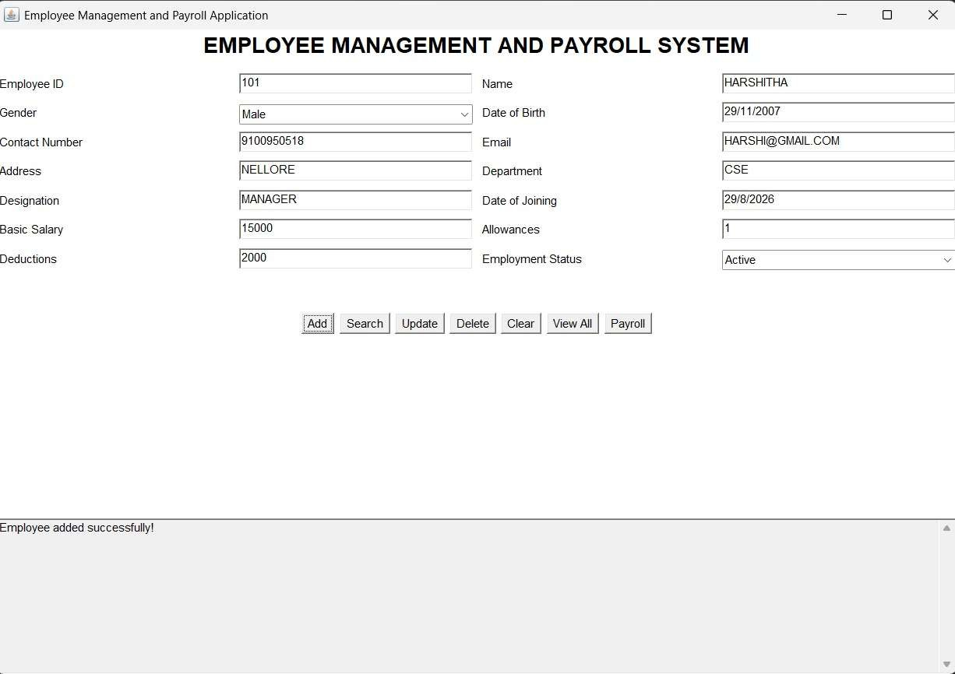
SEARCH

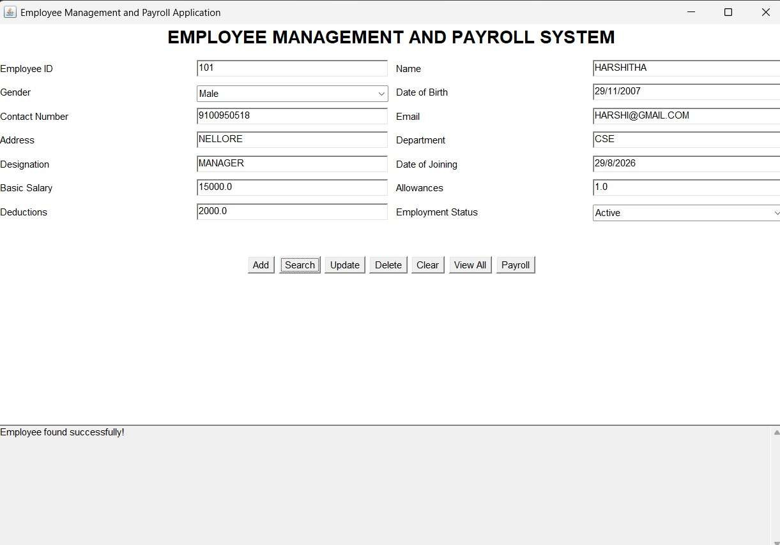

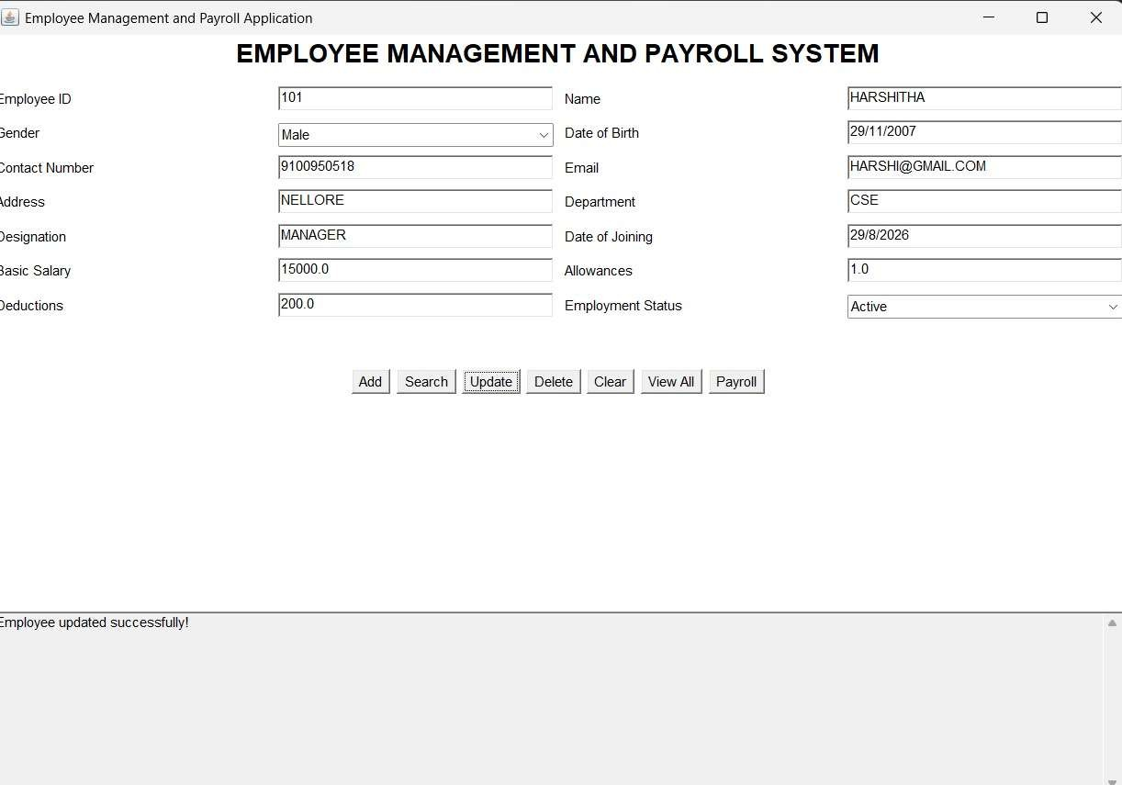
UPDATE
DELETE
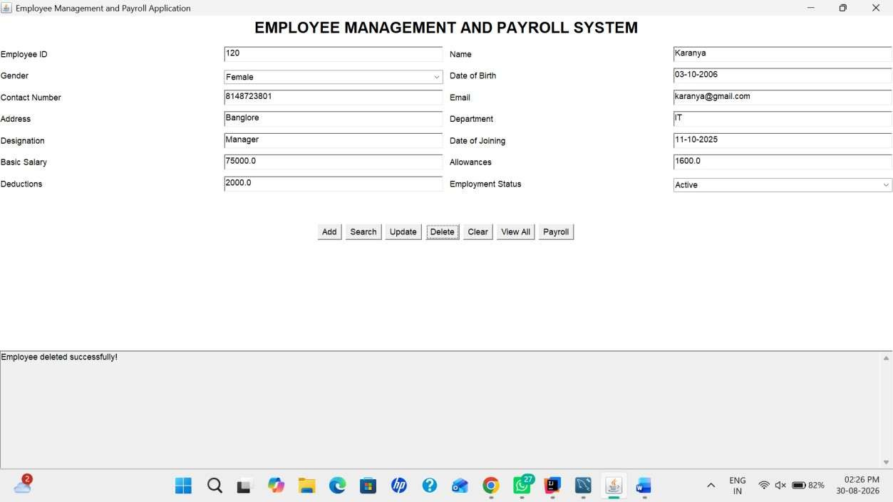

CLEAR
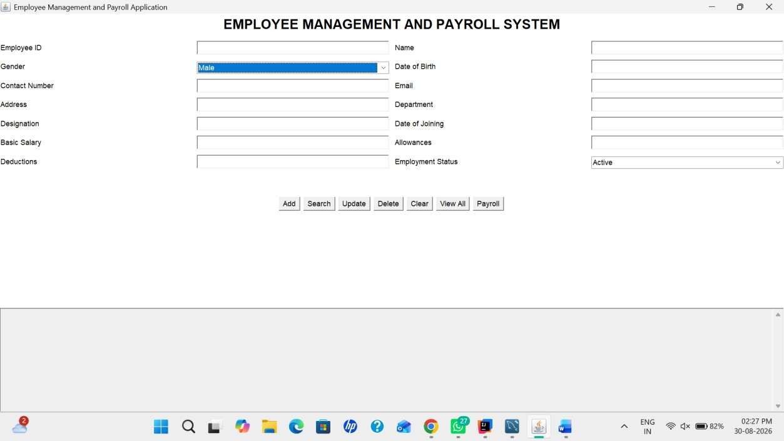
VIEWALL
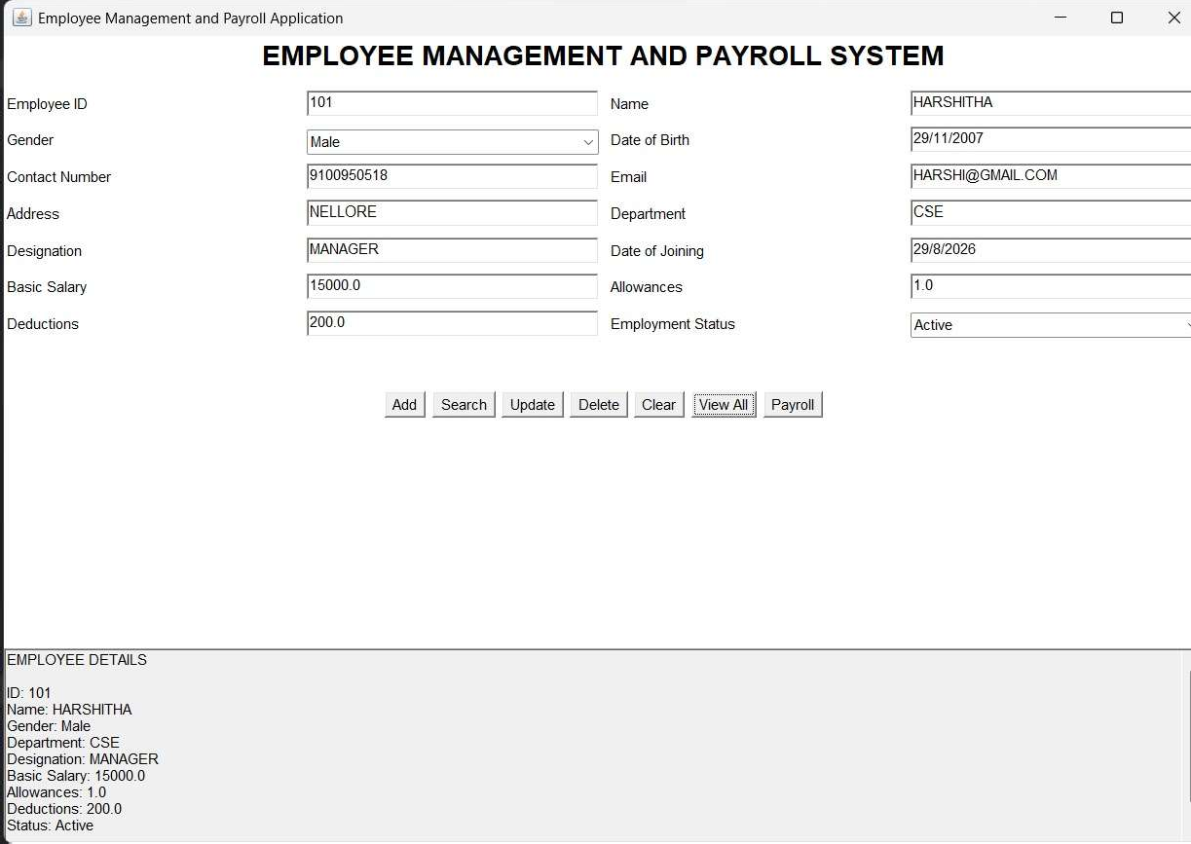

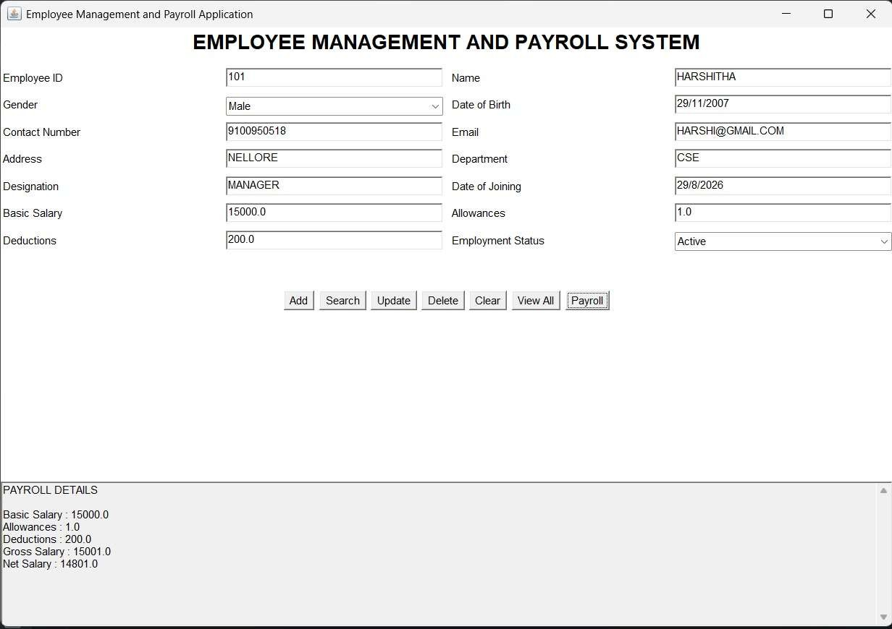
PAYROLL

